# 

### **CE3606 :: JavaScript 2: Advanced JavaScript for websites and Web Applications**

# 

# 

# 

# 

# 

# Lecture 10 pt1

## **Exercises sheet**

## **Aristos Markogiannakis**

## 

## **Please use these notes together with my lecture presentation.**

**Exercise 1 – Connecting to an API**

The following steps we will follow to build our react app.

**Note: You will need to look into the code in the notes to fill in the gaps inside the code that you are given here.**

**Step 1**

To avoid the burden of doing the webpack configuration we can simply install the

Create React App – More info can be found below

<https://reactjs.org/docs/create-a-new-react-app.html>

For now, what we need to do

Open the Visual Studio and then

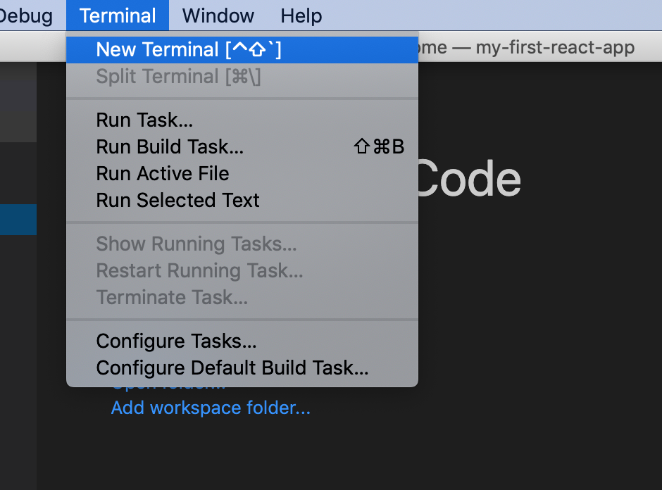

In terminal type the following:

**Step 1a:**

npx create-react-app react-api-app

cd react-api-app

npm start

**Step 2:**

Create the **components** and **containers** folders on the root of the app.

**Step 3:**

Inside the **containers** folder create a file **Rates.container.js** file

**Step 4:**

Inside the components folder create:

* List component **List.js**
* And a css file **List.css**

**List.js**

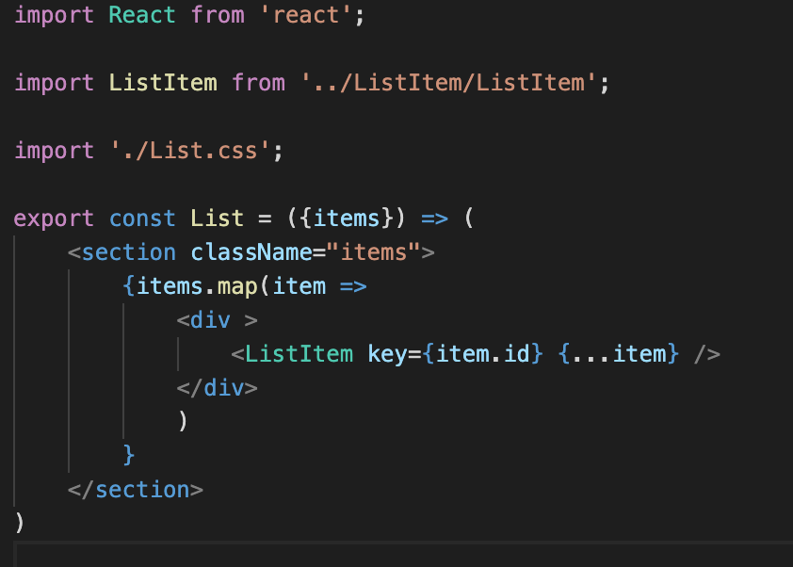

**List.css**

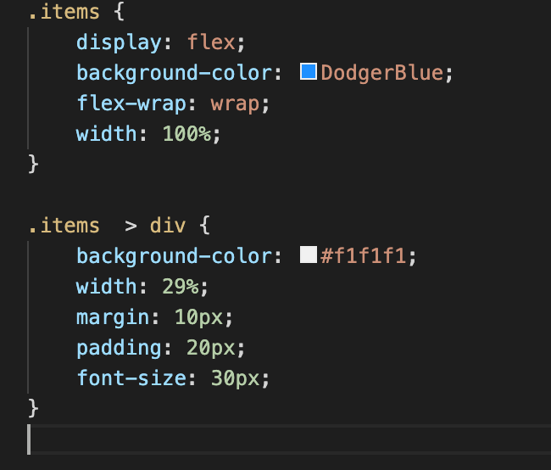

**Step 5:**

Create a ListItem component on the same folder (components), you will need to create

a) ListItem.js

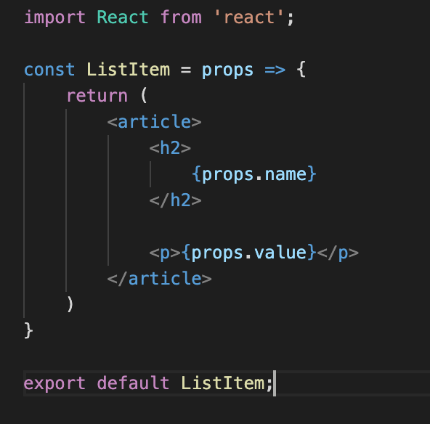

**Step 6:**

Type the following code inside the file **Rates.container.js**

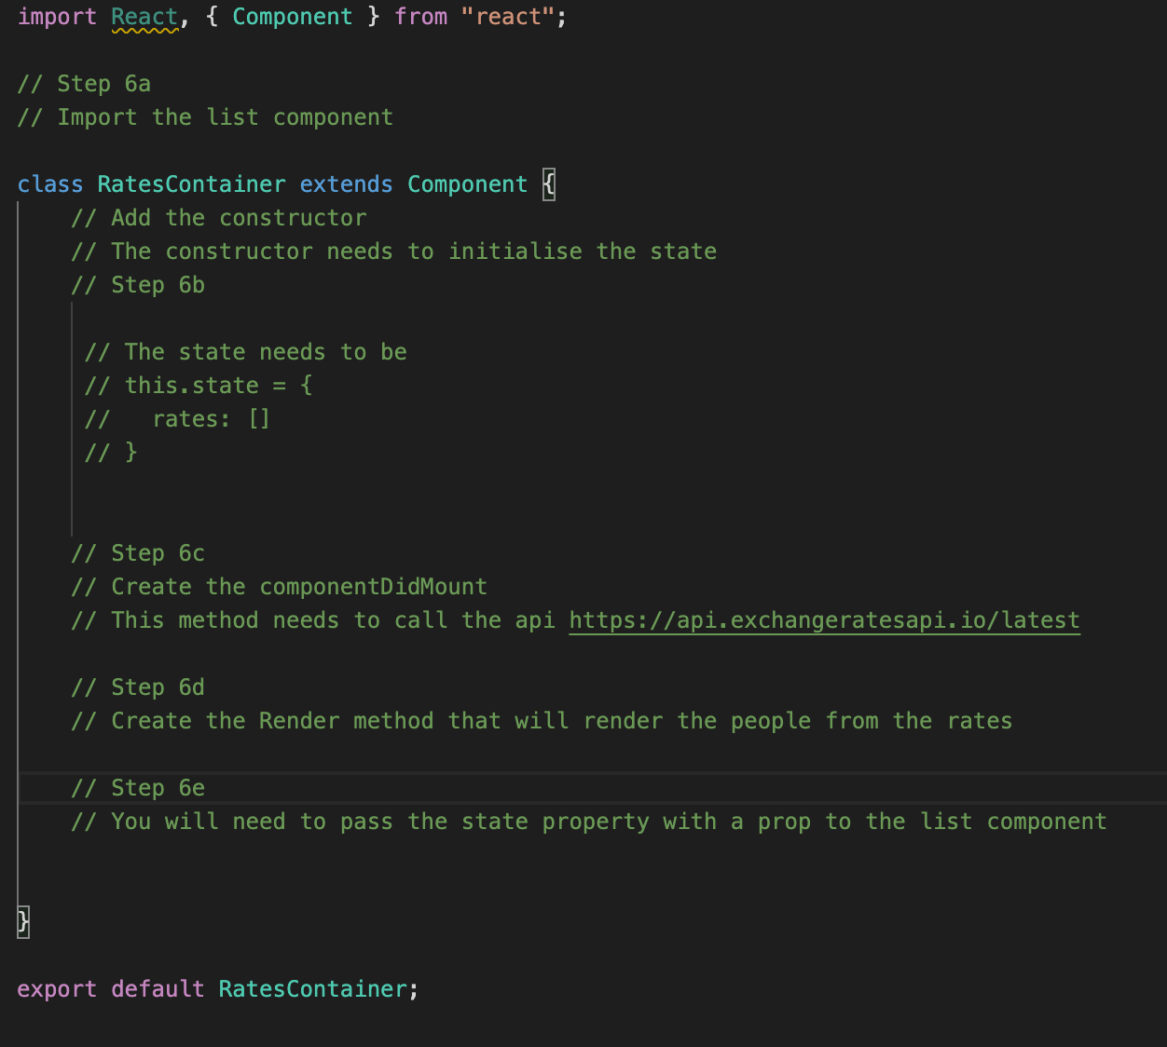

**Step 6a:**

Import the List component

**Step 6b:**

Add the constructor to your component, on the same method initialise a state property named **rates** and initialise it to an empty array.

**Step 6c:**

Add the ComponentDidMount method and add a fetch method to get your data

**Step 6d:**

Add the render method

**Step 6e:**

Inside the render method add the following code

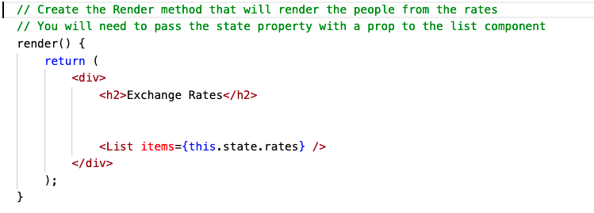

**Step 7:**

Update the App.js to the following image (**NOTE correction** sw = Rates.container.js) and RatesContainer

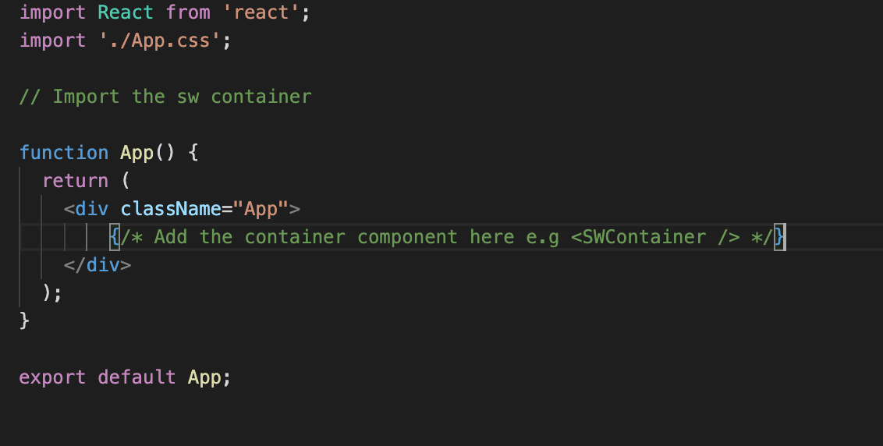

You will need to:

A) Import the rates container from the containers folder.

B) Add the container tag inside the div with className=”App”.

**Step 8:**

**To run the app you will need to run yarn start (or npm start)**

If everything is correct you will get the following screen.

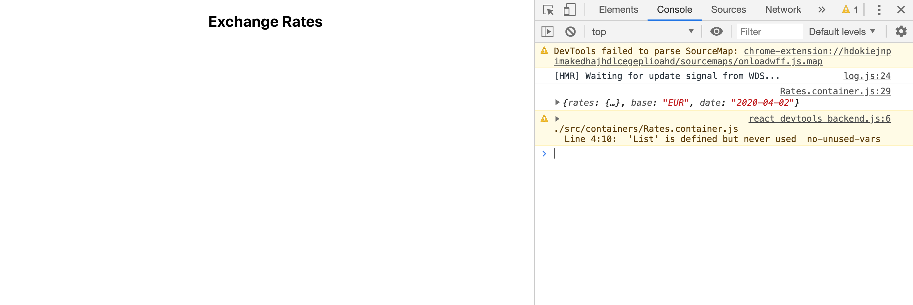

Where it prints only the h2

**Step 9:**

Inside the componentDidMount you will need to add some code:

* Fetch the data from <https://api.exchangeratesapi.io/latest>

If you navigate on this url you will see the data structure

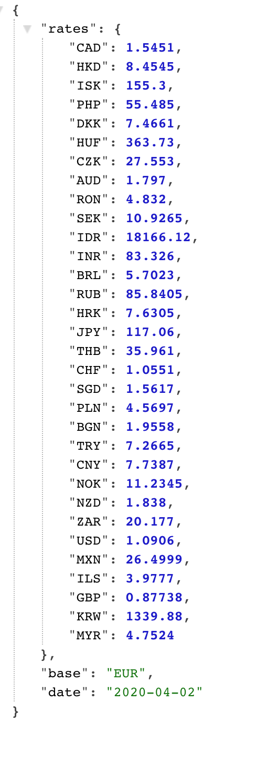

* Manipulate the data to a new format

You will need to use a for in loop to modify the data before you pass this data to the state

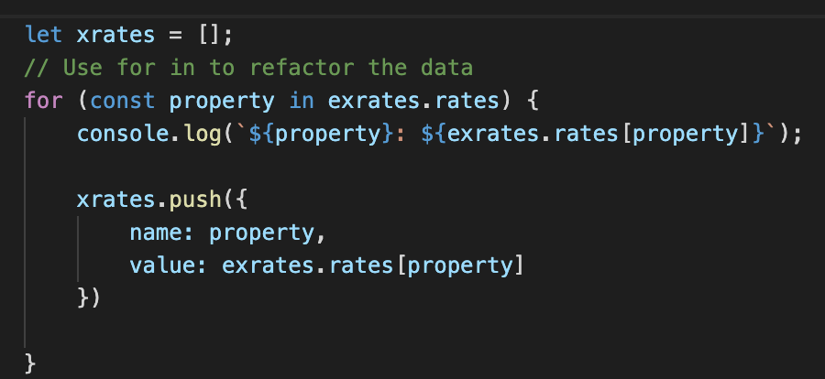

* Set the new state variable xrates to the data that you get from the fetch.

**Try to find this from my notes.**

The final result should be as the following image

